1. **Agenda**:
   1. Let’s see the psychology of the hammer pattern.
   2. Why this hammer pattern is called bullish pattern?
2. 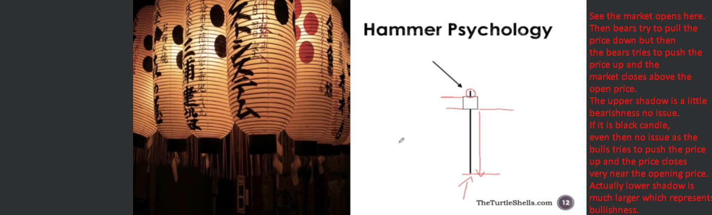
3. Let’s try to understand by example.  
   A graph with red text

   Description automatically generated with medium confidence  
     
   A graph of a stock market

   Description automatically generated with medium confidence
4. A graph with a line graph

   Description automatically generated with medium confidence